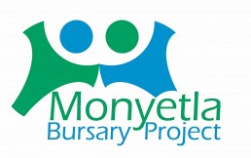
ENGLISH HL 14 March 2026 GRADE 12 LANGUAGE NOTES: Paper 1
Cartoons
Notes Compiled by Ms J.Govender
Cartoons
WHEN ANALYSING A CARTOON, LOOK AT THE FOLLOWING ASPECTS:
ACTION: What is happening in the cartoon?
CHARACTERS: The relationships between characters?
LANGUAGE: How has punctuation/words -used to suggest emotion?
SETTING: Where and when is the cartoon set? Observe surroundings (background and foreground)

FACIAL EXPRESSIONS:
- Raised eyebrows: shock, enthusiasm, interest
- Furrowed eyebrows: scepticism, concentration focus, frustration
- Frown: sadness, confusion
- Smile: joy, pleased, satisfaction
- Enlarged eyes: shock, admiration, energetic
- Rolled eyes: annoyance, frustration
- Wide open mouth: excitement, shock, enthusiasm
- Smirk: satisfaction, conceited, smug, self- satisfied, playful
- Grimace: pain, disgust, disapproval

BODY LANGUAGE:
- Outstretched arms: exaggeration, emphasis
- Slumped posture: uninterested, bored, tired
- Head buried hands: overwhelmed, frustrated, tired, crying
- Head placed on one hand: annoyance, impatience, frustration
- Head/ body turned away: disinterested, ignoring someone/something
- His fury is indicated by his clenched fists; he gnashes his teeth; he is sweating, as shown by the droplets.
- The action lines around his arms and legs reinforce the sense of his anger.
- Pointing/wagging index finger.
- Hand on hips – in control.

CARTOON TERMINOLOGY
TERM | EXPLANATION
FONT | It refers to the size and type of letters used. Larger or bold letters are used for emphasis.
PUNCTUATION | Clever use of Punctuation to create meaning. !!!!!
Tone | The most important way in which words can create comic effect is through the tone used. Ask yourself the following questions.  - Is the writer being serious?  - Is he mocking?  - Is there a contract between seriousness of the character and the absurdity of the situation?
Caricature | When one or more physical features is exaggerated to convey a message. E.g. Huge hands that reach out could show that someone is greedy.
Climax | The climax of the cartoon is the most exciting or important moment in it, usually near the end, often after a series of events.
Ellipses | An ellipsis can show that a thought is extended and that the reader should consider what has been said.  It can show hesitation in the speaker.  It can create suspension.
Contrast between frames …., action, font and diction/ Attitude | Action: In frame 2, the speaker is contemplative and passive. In Frame 4, the scene is in stark contrast to Frame 2. The girl shouts, as indicated by her wide open mouth, and it results in the boy's tumbling on the bed. The action lines clearly demonstrate the difference between Frames 2 and 4.  Font: The font in Frame 4 is bold as opposed to the smaller font in Frame 2. This highlights how the girl shouts out her statement.  Text: The diction in Frame 2 denotes her sincere (or apparently sincere) 'caring' concern at waking her brother, whereas, in Frame 4, she is bullying and this is shown by the domineering tone.
Layout | Slanted frames- disorientation.
Absence of dialogue | Character is shocked/lost for words. Looking directly at the reader as they are in a helpless situation.
PARODY | An imitation of a piece of writing used to ridicule the original or create a satirical point.
Movement Lines | These lines are squiggles that indicate movement or a specific action.  A powerful punch can be indicated by sharp movement lines around a hand and the person who is hit, this will then show aggression, anger etc.
Thought Bubble | A character is very deep in thought/ concentrating hard and is thus not speaking.  Someone has a thought but does not want to say it aloud; they do not want others to know what they are thinking.  This could be an exclamation, or a ‘secret’ comment, example: A character is annoyed with their classmates but will not voice their irritation (it stays in their thought bubbles) as it will lead to more, unnecessary conflict.  It could also show the thought process behind what has been said, for example: the thoughts of a child before asking their parent for money
POINT OF HUMOUR
Stereotype | A fixed, generalised image of a character or person.  NOTE: Advertisers often create  stereotypical images in order to appeal to a specific target audience,  e.g. the dumb blonde, the perfect mother, the jet setter, the popular teenager.  Name the stereotyping and then say how it contributes to the effectiveness of the cartoon.
Sarcasm | One thing is said but something else is intended, like irony. The difference is that sarcasm intends to hurt, insult or humiliate.  “You must have worked very hard to be at the bottom of the class!” “Oh, you think you’re God’s gift to mankind, don’t you?”
Anti-climax (Bathos) | This is when tension is created and we expect something important or exciting to happen, but instead, the ending is very ordinary or a let-down.  A build-up of ideas, but the final statement is often flat and unexpected. Humour is created.  They lost everything in the fire: their home, their possessions and their lunch.  I intend to be a great writer, to write short stories and letters to the press.

Satire | In an amusing way, social or political weaknesses or stupidities are highlighted. The satirist uses sharp wit, irony or sarcasm to expose these follies.
Pun | The play on words is where two possible meanings of a word are referred to, one of them the expected meaning, the other an absurd or comic meaning in context.
Irony | When one thing is said, but something else is meant.

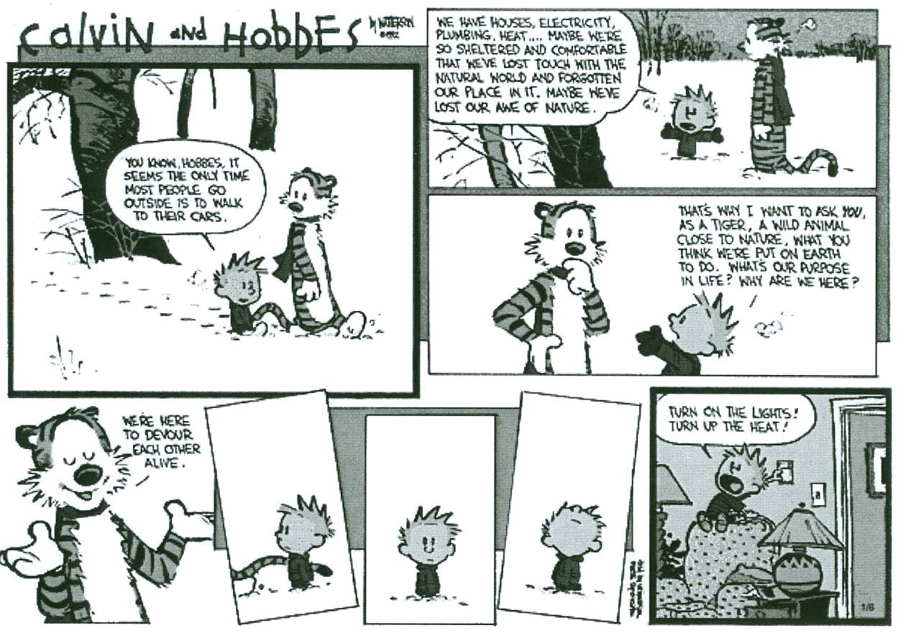
QUESTION 1: UNDERSTANDING OTHER ASPECTS OF THE MEDIA
YOU KNOW, HOBBES, IT SEEMS THE ONLY TIME MOST PEOPLE GO OUTSIDE IS TO WALK TO THEIR CARS.
WE HAVE HOUSES, ELECTRICITY, PLUMBING, HEAT ... MAYBE WE’RE SO SHELTERED AND COMFORTABLE THAT WE’VE LOST TOUCH WITH THE NATURAL WORLD AND FORGOTTEN OUR PLACE IN IT, MAYBE WE’VE LOST OUR AWE OF NATURE.
Frame 2
Frame 3
THAT’S WHY I WANT TO ASK YOU AS A TIGER, A WILD ANIMAL CLOSE TO NATURE, WHAT YOU THINK WE’RE PUT ON EARTH TO DO. WHAT’S OUR PURPOSE IN LIFE? WHY ARE WE HERE?
Frame 1
WE’RE HERE TO DEVOUR EACH OTHER ALIVE.
TURN ON THE LIGHTS! TURN UP THE HEAT!
TEXT A
1.1 | Explain what the language and illustration in frame 1 reveals about the  relationship between Calvin and Hobbes. | (2)

1.2 | Suggest why the tiger's body language changes from frame 3 to frame 4. | (2)

1.3 | Discuss how humour is created in this cartoon. | (3)

1.4 | Refer to frames 5, 6 and 7.  Comment on the effectiveness of the techniques used by the cartoonist in these frames.(2)  MARKING GUIDELINES -TEXT A
  1.1 | The footprints suggest that they have been walking together for a while. They are walking side-by-side and Hobbes is listening attentively to Calvin. The language used reveals the friendship that exists between the characters. The casual tone indicates that they are comfortable with each other. | (2)
  1.2 | The tiger is contemplative. He is perplexed by the question that Calvin has posed. In frame 4, his confidence/smugness is apparent. Hobbes is a tiger –  a carnivore/a clever cat that 'devours' the living. | (2)
  1.3 |  | Humour is created through the use of irony. In frame 2, Calvin is philosophical and preaching to the tiger about how humans have lost touch with nature because of their need for comfort. However, in frame 8, it is evident that Calvin himself has difficulty in surviving without modern comforts. When he grasps that nature is deadly dangerous, he desperately wants the protection offered by the modern world.
   | 1.4 |  | The slanted panels/frames accurately capture Calvin's sense of isolation/ inability to respond to the tiger's remark.  The lack of text and speech bubbles is effective in conveying confusion.  In frame 5, we only see a piece of the tiger's tail, which makes us wonder whether the tiger will act on what he suggests in frame 4.  The direction in which Calvin is facing in each of the frames is an indication of his disorientation/fears/confusion about the friendship he shares with the tiger.  TEXT B |  | (3)  [10]
2.4 Account for the change in Margaret’s body language from Frame 1 to Frame 2. (2)
2.5 Discuss the humour in the cartoon. (2)
2.6 Refer to frame 2.
Rewrite Dennis’s response to Margaret in grammatically correct English. (1)

MARKING GUIDELINES -TEXT B
2.4 Frame 1: Margaret is confident and relaxed; her hand is raised as she corrects Dennis, and she is smiling. (2)
Frame 2: Margaret is surprised/shocked/astonished by Dennis’s reply; her hands are on her hips and her mouth is drawn round as if in surprise.
Both frames must be discussed for two marks to be awarded. (2)
2.5 It is funny that Margaret intends to correct Dennis’s incorrect grammar, while he thinks that she is confused. / Dennis misinterprets Margaret’s response, he thinks that Margaret does not have the facts correct. (2)
2.6 No, Margaret, Joey and I! You weren’t (were not) there! (1)

TEXT C

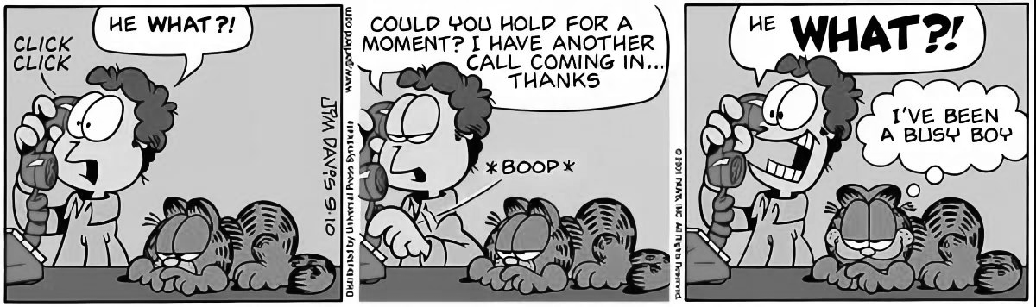
FRAME 1 FRAME 2 FRAME 3
3.1 Refer to FRAME 3.
Provide ONE visual and ONE verbal cue indicating that Jon is speaking very loudly. (2)
3.2 Refer to FRAME 2.
Account for the use of the ellipsis in this frame. (1)
How do Garfield’s thoughts and facial expression contribute to the humour in the cartoon? (2)
3.3 Refer to FRAMES 1 and 3.
Critically discuss the change in Jon’s facial expression and how it contributes to his state of mind.
There should be a clear distinction between the two frames and what his state of mind may be in each frame. (2)
3.4 Refer to FRAME 3
How do Garfield’s thoughts and facial expression contribute to the humour in the cartoon? (2)

MARKING GUIDELINES -TEXT C

3.1 Visual: Jon’s mouth is wide open, indicating that he is speaking very loudly or that he is screaming.
Verbal: The word, ‘WHAT’ is in capital letter and in bold print. / The question mark and exclamation mark indicate that Jon is speaking loudly.
3.2 It indicates that he has not completed his sentence/has not finished speaking. OR
It can indicate a pause before Jon ends the call.
3.3 In FRAME 1 Jon’s eyes are open but looks quite normal and his mouth is slightly open, indicating that he may be a bit surprised or irritated by what he has been told over the phone.
In FRAME 3 his eyes are wide open and bulging and his mouth is also wide open showing his teeth, indicating that he is speaking very loudly and that he is now thoroughly upset/mad/angry/shocked by what he has been told.
3.4 Garfield is quite content. His mouth is turned slightly upward in a sort of a smile while Jon is utterly shocked and angry by what Garfield has done. Garfield’s thoughts show that he does not see what he has done as being bad. He was just a busy boy (understatement). The contrasting visuals and reactions of the two characters contribute to the humour in the cartoon.

TECHNIQUES
AMBIGUITY is a possible double meaning which may make a message unclear when used by mistake (e.g. The lady hit the man with the umbrella) or create humour when used deliberately.
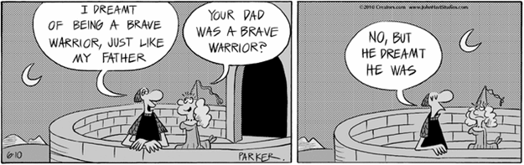
HOMONYM
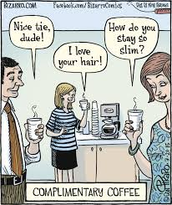
A homonym is a word which has both the same sound and spelling as another word but a different meaning (e.g. the noun bear and the verb to bear).

HOMOPHONE
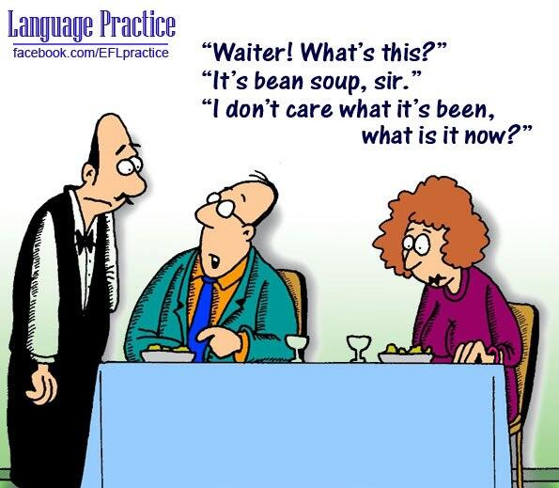
A homophone is a word which sounds the same as another but is spelled differently and has a different meaning (e.g. one and won)

PUNS
A pun is a play on words.
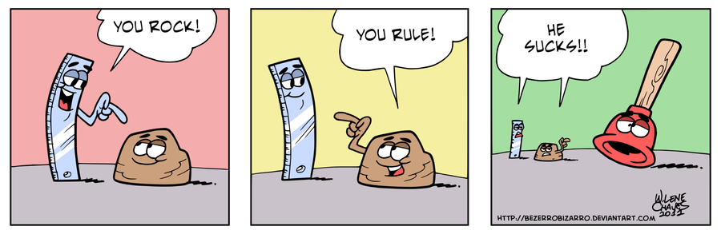
LITERAL LANGUAGE AND FIGURATIVE LANGUAGE.

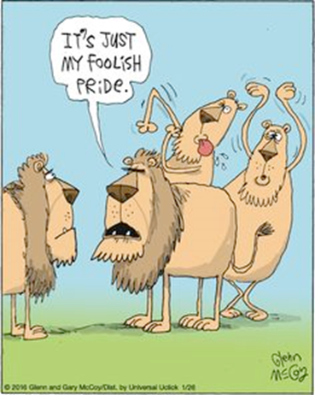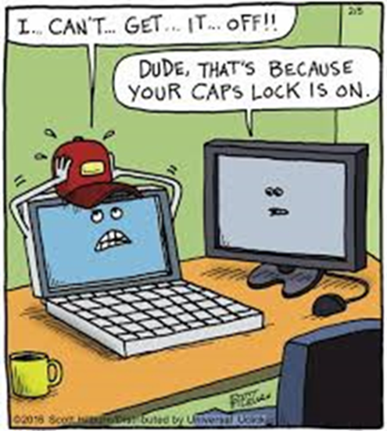
Literal language means exactly what it says, while figurative language describes things by using figures of speech. Figurative expressions are descriptive and not literal. Humour is often derived from depicting figurative language literally.

IRONY
There are three types of Irony:
- Verbal irony
- Situational irony
- Dramatic irony

Verbal Irony
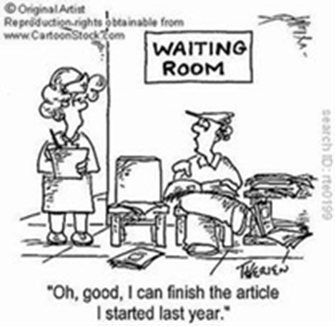
Verbal irony is the use of words to mean something different from what a person actually says. The main feature of verbal irony that sets it apart from the other different types of irony is that it is used by a speaker intentionally. It occurs in a conversation where a person aims to be understood as meaning something different to what his or her words literally mean.

DRAMATIC IRONY
- This type of irony is popular in works of art such as movies, books, poems and plays.
- It occurs when the audience is aware of something that the characters in the story are not aware of.

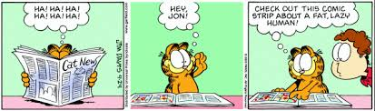
SITUATIONAL IRONY
It involves a discrepancy between what is expected to happen and what actually happens. Situational irony occurs when the exact opposite of what is meant to happen, happens.

